TECHNICAL BULLETIN
FOR KS TELECOM DEALERS AND DISTRIBUTORS

Subject: Installing KDX-500 Digital DSS

To ensure proper operation make sure to set the Dip Switches on the bottom of the DTDSS before installation.

The DTDSS requires the B1 or B2 channel of a DSU-A circuit.

Dip Switch 3 and 4 “ON” will select the B1 channel. Dip Switch 1 and 2 “ON” will select the B2 channel.
The most common applications will use the B1 channel for the Digital phone and the B2 channel for the DTDSS. If needed, more than one DTDSS can be used per Digital phone.

The DTDSS will always work with the Previous port. When using the 1st DTDSS on the B1 channel it will work with the Previous Circuits B2 channel.
Example: below shows the DTDSS set for the B2 channel.

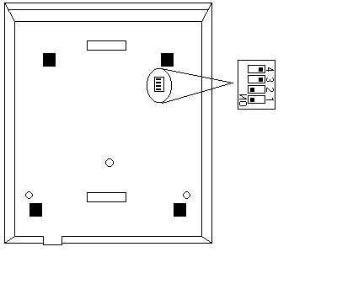
Bottom of DSS
REF.9111101

