TECHNICAL BULLETIN
FOR KS TELECOM DEALERS AND DISTRIBUTORS

Subject: Software change procedure for KDX-500 System.

The following procedure is a step by step process for updating the system software.

Step 1: Power down KSU and remove CCU-A card.
Step 2: Locate software EPROM u1 on CCU-A card and remove. Replace with EPROM supplied by Key System U.S. Make sure the notch on the chip is aligned with the notch on the socket and that all pins are properly aligned.
Step 3: *Default System by turning Dip Switch 1 on DSW1 to the "OFF" position and re-insert CCU-A card.
Step 4: Power up KSU and check phones for proper operation.
Step 5: Turn Dip Switch 1 on DSW1 to the "ON" position and re-program system.

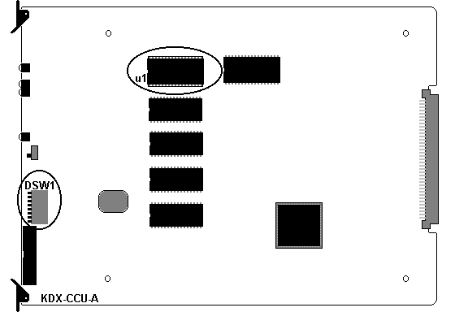
*Note: When updating software with the same version number (e.g. Version 50h 4/4/99 to Version 50h 6/1/99) System Default is optional.

REF: 9082401

