TECHNICAL BULLETIN
FOR KS TELECOM DEALERS AND DISTRIBUTORS

Installation and Programming the System 56 Caller I.D. Option

With the installation of this option, the System 56 can handle up to 16 Caller I.D. lines providing the C.O. delivers Caller ID (CLID) in the FSK format. When installed the System 56 will display Name or Number for incoming calls, on the Atlas LCD Phone.

This document provides instructions for installing and programming the System 56 CLID card(s). You can install up to 2 CLID cards (8 ports each) to the 10”x11.75” mounting plate. Note: This is the same mounting plate used for the System 56 Voice Mail.

Hardware / Software needed:

• 10 x 113/4 metal mounting plate with hardware. i.e. standoffs, screws cables.
Note: When the System 56 is equipped with optional Voice Mail, the mounting plate might not be needed.
• 1 to 2 Caller I.D. cards (8 ports ea.) Depending on number of C.O. Lines.
• System 56 software version 50i dated 2001/11/26 or later.

Installation

The first step in the installation is to setup the metal mounting plate that will provide the mounting post for the CLID card. If the optional voice mail is already installed then the CLID card(s) will mount to the standoffs located above the Voice Mail. Install the 5/16” Standoffs and nuts provided to metal mounting plate as indicated in Figure 1.
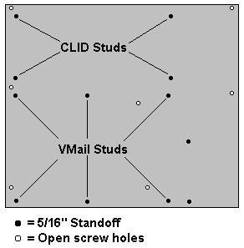

Figure: 1
The metal mounting plate will install in the top portion of the System 56. You will need to remove the top 7 screws of the Main System 56 board and replace the screws with the 7- 1” standoffs provided. Once the standoffs are in place and the mounting plate has been properly setup, line up the mounting holes in the plate to the standoffs and secure with the 7 machine screws provided. See Figure 2
NOTE: Make sure to install the 10 conductor multi –colored ribbon cable to J2 connector of the main System 56 board before securing!!! See Figure 2
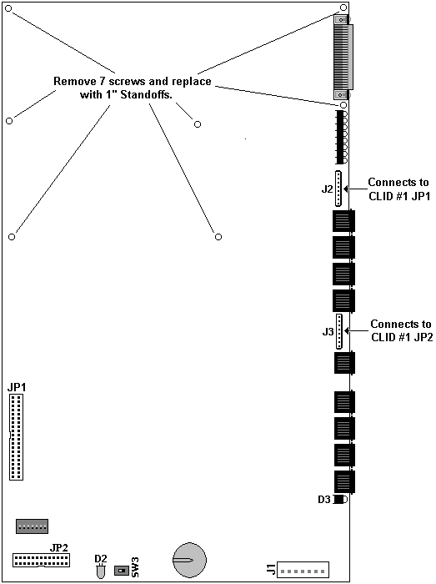
Figure: 2

Each CLID card has 1-26 pin connector (JP1) for the System 56 interface, 2-10 pin connectors (J1, J2) for C.O. line interface and 2 jumpers (JP1, JP2) for determining Main CLID (CLID #1) or Expansion CLID (CLID #2) interface. See Figure 3

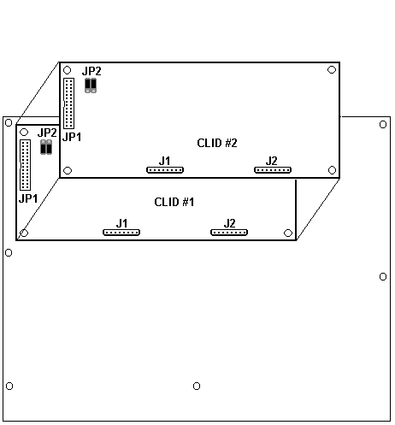

Figure: 3

The connections to the System 56 are as follows:

CLID #1

CLID #1 JP1 - connects to System 56 JP2 (located in lower left corner of System 56 Main board). Note: remaining connector on ribbon cable is for the CLID #2 card.
CLID #1 J1 - connects to System 56 J2 (located above C.O.line connections on System 56 Main board).
CLID #1 J2 - connects to System 56 J3 (located below C.O.line connections on System 56 Main board).
JP1 and JP2 jumpers must be in the MAIN position.

CLID #2

CLID #2 JP1 - connects to CLID #1 JP1
CLID #2 J1 - connects to System 56 J2 (located above C.O.line connections on System 56 Expansion board).
CLID #2 J2 - connects to System 56 J3 (located below C.O.line connections on System 56 Expansion board).
JP1 and JP2 jumpers must be in the EXPANSION position.

Programming

Caller ID is active by default and will display the 10-digit number when a call is ringing at any Atlas LCD telephone. The CLID information will follow the call when transferred via Voice mail to any Atlas LCD users.
CLID information cannot be viewed from CLID compatible single line devices. i.e. cordless phones, stand alone CLID boxes.

Related System 56 programming:

Caller ID Name - Section 1 Mode 05 - The System 56 can be programmed to show the Name instead of Number as the incoming call is received. Default= NO (Show Number)

Show Caller ID – Section 2 Mode 26 - Using this program each Atlas LCD user can be restricted from viewing the CLID information. Default= YES (Show CLID).

CLID button – Section 2 Mode 73 – A button can be programmed to toggle between Name or Number during ringing calls or while on the call. Default= Not Assigned

NOTE: The CLID information (FSK) is sent from the Telco between the 1st and 2nd ring. When using the Auto Attendant feature of the Voice Mail, you may need to program a Ring Delay of 4-6 seconds in order for the System 56 to process the FSK packets sent by the Telco.
Failure to program a Ring Delay may result in missed or inconsistent CLID information.

Refer to Ring Delay programs in System 56 Programming Manual. (Sec.1 Mode 60,62,67,69,73 & 75)

