TECHNICAL BULLETIN
FOR KS TELECOM DEALERS AND DISTRIBUTORS

PRODUCT: ATLAS 56
SUBJECT: Digital Phone Lock up
VERSION: All Versions

Certain digital phones may lock up, freeze or automatically seize lines until reset by unplugging the phone. This problem can be corrected by replacing the DSLIC’s (UA26-UB-26) on the MAIN MCB/EXP. MCB unit(s).
Power Down system and remove cover. If system is equipped with Voice Mail, remove the Voice mail mounting plate for access to DSLIC’s. If defective DSLIC is on the Expansion card the Main MCB Unit must also be removed.

Using a PLCC extractor remove the defective DSLIC and replace with the factory supplied DSLIC. Once replacement IC is correctly aligned in socket press firmly into place.

Refer to drawing below for locating DSLIC’s.

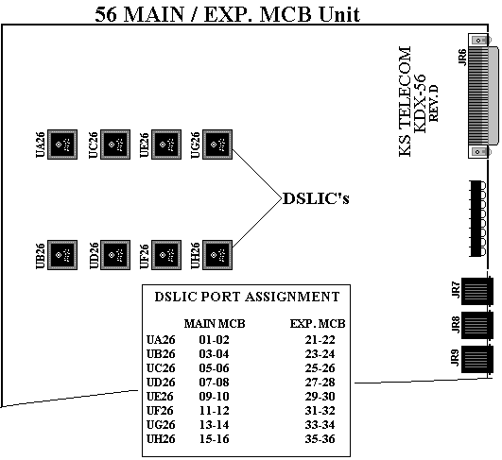
REF:2011801

